CSE 2221: systemS programming

Lab 04

Writing Shell Scripts
VI EDITOR:-

$ vi [options] file_list
Purpose: Create a file with the given file name
Change mode in vi editor
i Insert mode
<esc> Command mode
a Append mode A (go to end line)
r Overwrite one character
R Keep overwriting
Delete from vi editor
nx Delete n characters
5dd Delete 5 lines
dl Delete to the end of screen
d$ Delete to the end of line
d5w Delete 5 words
32 d 8 Delete 8 lines after line 32
Saving chages and quitting from vi editor
Save and exit from vi
<shift- zz)
Shell:-
A program that takes the commands you type and translates them into instructions to the
operating system.

How to Run Shell Scripts
There are two ways you can execute your shell scripts. Once you have created a script file:

Method 1
Pass the file as an argument to the shell that you want to interpret your script.

Step 1 : create the script and save it with .sh
For example, the script file show has the following lines
echo Here is the date and time
date

Step 2 : To run the script, pass the filename as an argument to the sh (shell )
$ sh show or sh show.sh
Here is the date and time
Wed Feb 23 13:40:15 PST 2012
Method 2:
Make your script executable using the chmod command.
When we create a file, by default it is created with read and write permission turned on and execute
permission turned off. A file can be made executable using chmod.

Step 1 : create the script using vi, ex or ed
For example, the script file show has the following lines
echo Here is the date and time
date

Step 2 : Make the file executable
$ chmod u+x script_file
$ chmod u+x show or $chmod u+x /home/mehreeen/show.sh
Step 3 : To run the script, just type the filename
$ ./ show.sh
Here is the date and time
Wed Feb 23 13:40:15 PST 2012

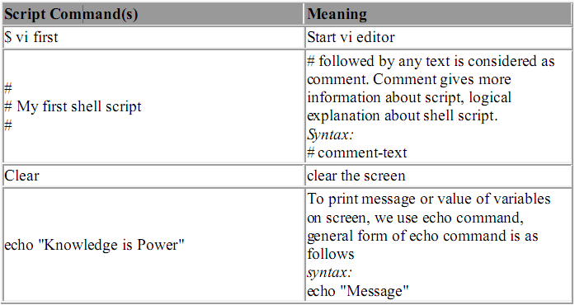

Variables in Shell

To process our data/information, data must be kept in computers RAM memory. RAM memory is divided into small locations, and each location had unique number called memory location/address, which is used to hold our data. Programmer can give a unique name to this memory location/address called memory variable or variable (Its a named storage location that may take different values, but only one at a time).
In Linux (Shell), there are two types of variable:

(1) System variables - Created and maintained by Linux itself. This type of variable defined in CAPITAL LETTERS.

(2) User defined variables (UDV) - Created and maintained by user. This type of variable
defined in lower letters.
You can see system variables by giving command like $ set, some of the important System variables are:HOME, USER

NOTE that some of the above settings can be different in your PC/Linux environment. You can
print any of the above variables contains as follows:

$ echo $USERNAME
$ echo $HOME

Exercise:
1) If you want to print your home directory location then you give command:

a)$ echo $HOME
OR

(b)$ echo HOME
Which of the above command is correct & why?

How to define User defined variables (UDV)

To define UDV use following syntax
Syntax:
variable name=value
'value' is assigned to given 'variable name' and Value must be on right side = sign.

Example:

$ no=10# this is ok
$ 10=no# Error, NOT Ok, Value must be on right side of = sign.

To define variable called 'vech' having value Bus
$ vech=Bus

To define variable called n having value 10

$ n=10

Rules for Naming variable name (Both UDV and System Variable)

(1) Variable name must begin with Alphanumeric character or underscore character (_), followed by one or more Alphanumeric character. For e.g. Valid shell variable are as follows

(2) Don't put spaces on either side of the equal sign when assigning value to variable. For e.g. In following variable declaration there will be no error

$ no=10
But there will be problem for any of the following variable declaration:

$ no =10
$ no= 10
$ no = 10

(3) Variables are case-sensitive, just like filename in Linux. For e.g.

$ no=10
$ No=11
$ NO=20
$ nO=2
Above all are different variable name, so to print value 20 we have to use $ echo $NO and not any of the following

$ echo $no # will print 10 but not 20
$ echo $No# will print 11 but not 20
$ echo $nO# will print 2 but not 20

(4) You can define NULL variable as follows (NULL variable is variable which has no value at the time of definition) For e.g.
$ vech=
$ vech=""

Try to print it's value by issuing following command

$ echo $vech
Nothing will be shown because variable has no value i.e. NULL variable.

How to print or access value of UDV (User defined variables)

To print or access UDV use following syntax
Syntax:
$variablename
Define variable vech and n as follows:

$ vech=Bus
$ n=10
$ echo $vech
$ echo $n

Caution: Do not try $ echo vech, as it will print vech instead its value 'Bus' and $ echo n, as it will print n instead its value '10', You must use $ followed by variable name.

$ vi variscript
#
#
# Script to test MY knowledge about variables!
#
myname=Vivek
myos = TroubleOS
myno=5
echo "My name is $myname"
echo "My os is $myos"
echo "My number is myno, can you see this number"

Shell Arithmetic

Use to perform arithmetic operations.
Syntax:
expr op1 math-operator op2

Examples:

$ expr 1 + 3
$ expr 2 - 1
$ expr 10 / 2
$ expr 20 % 3
$ expr 10 \* 3
$ echo `expr 6 + 3`

Note:
expr 20 %3 - Remainder read as 20 mod 3 and remainder is 2.
expr 10 \* 3 - Multiplication use \* and not * since its wild card.

For the last statement not the following points
(1) First, before expr keyword we used ` (back quote) sign not the (single quote i.e. ') sign. Back quote is generally found on the key under tilde (~) on PC keyboard OR to the above of TAB key.
(2) Second, expr is also end with ` i.e. back quote.
(3) Here expr 6 + 3 is evaluated to 9, then echo command prints 9 as sum
(4) Here if you use double quote or single quote, it will NOT work

For e.g.

$ echo "expr 6 + 3" # It will print expr 6 + 3
$ echo 'expr 6 + 3' # It will print expr 6 + 3

More about Quotes
There are three types of quotes

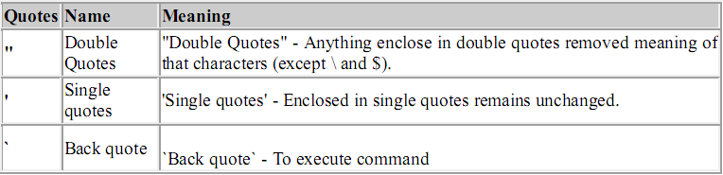

Example:

$ echo "Today is date"
Can't print message with today's date.
$ echo "Today is `date`".
It will print today's date as, Today is Tue Jan ....,Can you see that the `date` statement uses back
quote?

Exit Status

By default in Linux if particular command/shell script is executed, it return two type of values which is used to see whether command or shell script executed is successful or not.
(1) If return value is zero (0), command is successful.
(2) If return value is nonzero, command is not successful or some sort of error executing command/shell script.
This value is know as Exit Status.
But how to find out exit status of command or shell script?
Simple, to determine this exit Status you can use $? special variable of shell.
For e.g. (This example assumes that unknow1file doest not exist on your hard drive)

$ rm unknow1file

It will show error as follows
rm: cannot remove `unkowm1file': No such file or directory
and after that if you give command

$ echo $?
it will print nonzero value to indicate error. Now give command

$ ls
$ echo $?

It will print 0 to indicate command is successful.
Exercise
Try the following commands and not down the exit status:

$ expr 1 + 3
$ echo $?
$ echo Welcome
$ echo $?
$ wildwest canwork?
$ echo $?
$ date
$ echo $?
$ echon $?
$ echo $?

Exercise
Q.1.How to Define variable x with value 10 and print it on screen.
Q.2.How to Define variable xn with value Rani and print it on screen
Q.3.How to print sum of two numbers, let's say 6 and 3?
Q.4.How to define two variable x=20, y=5 and then to print division of x and y (i.e. x/y)
Q.5.Modify above and store division of x and y to variable called z

Writing C codes in Linux:

Step 1 : Use an editor, such as vi, ex, or ed to write the program. The name of the file
containing the program should end in .c.
For example, the file show.c contains the following lines :
main()
{
printf(“ Hello World “);
return 0;
}
Step 2 : Submit the file to GCC ( the GNU C Compiler )

$ gcc –o show show.c

If the program is okay, the compiled version is placed in a file called show.out
Step 3 : To run the program, type show.out

$ show.out or ./show

Hello World

Practical Assignment 1: Due date 19th February 2013.

Question 1: Write a program of factorial and display the result.
Question 2: Write a program in C that can calculate the sine, cosine and Tan of a given angle using the look-up table technique..
Question 3: Write a program to convert Kenya shillings to USA dollars, when the user inputs the amount in Kenya shillings. (Let Kshs. 87.95 = 1 US Dollar).
Question 4: Write a program that inputs an integer from the keyboard and displays its square.
Question 5: Write a program that reads your first name and surname when you enter them. Each part of your name should not be more than 12 characters. Finally, have the program display your full name.
Question 6: Write a program that calculates the two roots x1 x2 with double precision, and displays the roots on the screen.
Question 7: The total mechanical energy of a particle is given by: Energy = mgh + ½ mv. Write a program to calculate the energy using the formula above. The data is to be input from the keyboard.

Question 8: Identify the errors in the following program and write an error free program.
#include <stdio.h>
VOID main[ ]
{
/* Radius, area and perimeter are declared to be floats /*
Float r, area, perimeter,
printf(\n “Enter the radius of the circle - > \n”);
scanf(“%f”,&r);
area = PI * pow(r, 2)
perimeter = 2 * PI * r;
/* Result is printed after the computation */
printf(“ Area = %f Perimeter = %d /n”, area, perimeter);
}

